

**A1: Big Data Analytics Sustainable Development APP**

**Submitted by: Madeleine Benna**

**Hult International Business School**

**Big Data Analytics for Sustainable Development - DAT-5328 - SFO1**

**Submitted to: Dr. Patrick Lynch**

**June 3, 2025**

Contents

Tide Together: A Community-Centered Mobile Solution for Whaleport’s Just Energy Transition 2

Introduction 3

Strategic Framework: Sustainability, Inclusion, and Ethics 3

Community-Informed Design 5

Features Overview and Technical Integration 6

AI and Big Data Applications 6

Civic Media Tools + Engagement 7

Accessibility & Language Support 8

Ethical Data Use 9

Economic and Environmental Impact 9

Risk Mitigation and Stakeholder Support 10

Conclusion 13

References 14

Appendix 15

# Tide Together: A Community-Centered Mobile Solution for Whaleport’s Just Energy Transition

## Introduction

Whaleport is a town that breathes with the rhythm of the sea. For generations, its fishing families have been more than workers—they’ve been stewards of ocean life and culture. The push toward 100% renewable energy by 2030 is bold and necessary—but only if it's just. TideTogether emerged from this tension: not as a product, but as a digital infrastructure for trust. While offshore wind and tidal energy promise cleaner power and new revenue streams, the fishing community—which contributes an estimated $400 million annually to the local economy—has voiced legitimate concerns (*Evaluating the Impact of Renewable Energy on Local Fishing Communities Report*, n.d.).

**Tide Together** is more than a mobile app. It is a **digital bridge** that connects clean energy ambitions with cultural preservation, ecological sensitivity, and the voices of everyday Whaleport residents. It puts power into the hands of those who fish, study, teach, plan, and care about the future of this coast.

## Strategic Framework: Sustainability, Inclusion, and Ethics

Just like I learned through adapting from biotech to data storytelling, TideTogether's structure is guided by *adaptability, integrity, and a growth mindset*. It integrates the following frameworks to create a grounded and values-based approach:

* **Triple Bottom Line (TBL):**
  + *People*: Empowers users with localized job training, storytelling, and compensation tracking.
  + *Planet*: Provides marine biodiversity alerts and season-sensitive zoning tools.
  + *Profit*: Ensures co-op earnings transparency and equitable economic participation.

This Triple Bottom Line (TBL) framework aligns with key recommendations outlined in the Feasibility Study Report and SWOT Analysis of the Whaleport Renewable Energy Project, which emphasize the need for socially inclusive job training (People), biodiversity mitigation strategies (Planet), and community-shared economic benefits through co-op earnings (Profit) as essential pillars for a sustainable and equitable energy transition (*Feasibility Study Report*, n.d.; *SWOT Analysis*, n.d.)

* **PESTLE Analysis:**
  + Used to map user pain points (e.g., lack of permit transparency, zoning confusion) into app features.
  + Captures Political (policy input), Environmental (zoning impacts), Social (heritage and inclusion), Technological (AI/GIS), Legal (permit alerts), and Economic (incentive tracking) dimensions.
* **Digital Inclusion Principles:**
  + Recognizes that older residents, low-income households, and non-English speakers are often left behind in tech transitions. As noted in the (*Environmental Impact Assessment*, n.d.), infrastructure alone isn't enough—access, literacy, and motivation must be addressed.

## Community-Informed Design

The design of TideTogether has been shaped by powerful insights from Whaleport residents themselves. According to the Local Community Feedback Report (2024), 75% of residents support the renewable energy transition, but 55% are concerned about job loss and 30% about environmental disruption. Importantly, over 80% voiced a desire for ongoing participation in zoning and feedback. Workshop participants emphasized that the real issue wasn't just jobs—it was *identity*.

"We're not against wind. We're against being left out of decisions about our own coast."

As someone who’s also navigated systems not built for me, I recognized the grief behind that line. To honor this, the app includes:

* **"Voices of Whaleport"**: a multimedia gallery where fishers, students, and residents share short video stories. Ensures they feel the app was made for *them*.
* **Role-based onboarding**: Different entry points for users depending on whether they're fishers, students, planners, etc.
* **Polling and alerts**: Real-time notification and participation tools tied to town hall events, marine conditions, or compensation updates.

## Features Overview and Technical Integration

AI and Big Data Applications  
TideTogether is not just a passive information app. It uses layered data from NOAA, wind speed records, and local zoning maps to:

* Generate **real-time overlays** showing turbine activity and safe fishing zones.
* Predict seasonal shifts in marine biodiversity—especially relevant for scallop spawning and migratory fish species.

Table 1.1

Table 1.2

Table 1.3

The data in tables 1.1, 1.2, and 1.3 above is a visual representation of (*Environmental Impact Assessment*, n.d.), demonstrates why *March to May* is a critical period for seabed protection, especially for Atlantic Cod. Haddock requires longer protections. These visualizations can inform **marine access alerts** and **construction blackout dates** in the app, as visualized in *appendix G.*

Artificial Intelligence (AI) is revolutionizing immersive experiences by enabling real-time personalization and adaptive storytelling. This technology can be leveraged to foster deeper connections within communities. For instance, AI-driven extended reality (XR) applications can create interactive simulations that allow residents to visualize the impact of offshore wind projects on their local environment, thereby promoting informed community participation (Sinai, 2024).

### Civic Media Tools + Engagement

* Push notifications for zoning, policy alerts, or co-op vote updates.
* Marine Pulse Feed *(Appendix F)* uses community tagging (e.g., #TurbineWatch) to build civic accountability.
* The “Community Pulse” feed (Appendix E) responds directly to the strong desire—expressed by over 80% of Whaleport residents—to be involved in ongoing decisions related to renewable energy zoning and marine (*Local CommunityFeedback Data*, n.d.). By allowing users to post tagged updates and participate in live polling, this feature acts as a digital extension of public workshops, ensuring community input continues between town hall meetings.

### Accessibility & Language Support

* Available in four languages (English, Spanish, Portuguese, Haitian Creole).
* Offline functionality, font scaling, narration mode.

### Ethical Data Use

* Opt-in location tracking.
* Clear consent toggles for every data input.
* Anonymous feedback modes for safety.

## Economic and Environmental Impact

Growing up, I believed tech should *serve*, not *replace*. TideTogether offers tools, not directives. It functions as an economic and environmental resilience tool:

* **Job Transition Tools:** Links to blue economy training at New Bedford NOWI (*Sustainability Resources and Interactive Tools*, n.d.). Circular Trade Dock *(Appendix B)* supports income security and waste reduction.
* **Environment:** Marine data integration from NOAA and local tracking tools.
* **Marine Health Indicators:** Integrated with NOAA and Whaleport biodiversity data.

Table 2.1

Data from local fishers underscores that the transition to renewable energy is not simply an economic issue—it’s a cultural one. According to community polling, 80% of fishers identified cultural identity as their top concern, revealing that the potential loss extends beyond income to the erosion of heritage, family legacies, and a deep-rooted way of life (*Local CommunityFeedback Data*, n.d.). Additionally, 75% expressed fear of stock collapse, driven by concerns that turbine installations could disrupt critical spawning areas or migration routes—emphasizing the importance of marine biodiversity mapping and construction blackout periods. Another 70% worry about losing access to fishing zones, highlighting the need for real-time zoning overlays and equitable permit systems. Lastly, 65% are concerned about underwater noise, pointing to growing awareness of how acoustic pollution affects marine species—and a demand for tech-based mitigation strategies. These insights justify Tide Together’s core features: dynamic zoning tools, marine condition alerts, and inclusive heritage storytelling that reinforces economic adaptation without cultural erasure.

The cruise and hospitality sectors have begun utilizing AI to enhance sustainability. Royal Caribbean, for example, employs AI to minimize food waste by analyzing consumption patterns and optimizing inventory management. Such applications demonstrate AI's potential in reducing environmental footprints, a practice that can be adapted to support sustainable fishing and tourism in coastal communities (Lastra et al., n.d.) .

## Risk Mitigation and Stakeholder Support

From the SWOT analysis (2024), key threats include policy delays, ecological backlash, and cultural resistance. Tide Together addresses these by:

* **Trust-building tools**: Transparent, bilingual policy updates and zoning overlays.
* **Gamification**: Encourage youth and new residents to report environmental changes or attend workshops.
* **Feedback loops**: Community alerts, report submission forms, and co-op vote integration.

The app is designed not just to distribute information, but to invite participation and increase the community’s sense of agency over the energy transition.

While AI offers numerous benefits, it's important to acknowledge its environmental costs. The energy consumption associated with AI operations is significant, with projections indicating that AI could account for nearly half of data center power usage by the end of 2025. This underscores the necessity of integrating renewable energy sources into AI infrastructure to align with sustainability goals (Calma, 2023) .

**Sustainability & Equity**

This proposal applies sustainability strategy in four dimensions, It supports SDGs 7 (Clean Energy), 8 (Decent Work), 13 (Climate Action), and 14 (Life Below Water).

**7: Affordable and Clean Energy**  
TideTogether directly advances this goal by supporting Whaleport’s 100% renewable energy target with **community-informed zoning, energy literacy features,** and tools to help residents access **training and co-op revenue participation.** It democratizes energy information in an accessible mobile format, particularly for underrepresented or digitally excluded groups.

**8: Decent Work and Economic Growth**  
The app links users to **blue economy jobs**, retraining programs (e.g., New Bedford NOWI), and **transparent earnings dashboards** for fishers involved in the renewable energy co-op. This ensures that displaced labor is not just acknowledged, but actively included in the green economy through real, dignified pathways.

**13: Climate Action**  
Through real-time alerts on biodiversity zones, safe construction timing, and public data sharing on turbine performance, Tide Together helps ensure that climate mitigation efforts do not result in ecological overreach or community backlash. It encourages data-driven, participatory climate planning.

**14: Life Below Water**  
The integration of NOAA data, AI-powered marine biodiversity overlays, and peer-sourced marine conditions directly protects marine life. The app’s blackout zones for spawning periods and noise mitigation features reflect an urgent commitment to **preserving aquatic ecosystems** while building sustainable offshore infrastructure.

Together, these elements turn Tide Together into more than just an app—it becomes a participatory governance tool, a climate justice platform, and a digital steward for coastal resilience.

The integration of artificial intelligence within the Tide Together platform strengthens its alignment with the United Nations Sustainable Development Goals, particularly **SDG 7 (Affordable and Clean Energy)** and **SDG 13 (Climate Action)**. By incorporating AI-driven features such as predictive biodiversity mapping, real-time zoning updates, and immersive community education tools, the proposal promotes informed energy transitions powered by clean, equitable technologies. Moreover, Tide Together **acknowledges the carbon cost of AI itself**, referencing recent findings that AI systems may consume as much energy as entire nations if left unchecked. This reinforces the platform’s commitment to climate responsibility by advocating for renewable-powered AI infrastructure and transparent data practices. In doing so, Tide Together models a responsible digital sustainability strategy that maximizes innovation while minimizing environmental harm—demonstrating that technological progress and planetary stewardship must advance together.

## Conclusion

Tide Together doesn’t pretend to fix centuries of cultural identity overnight. It opens a line of communication, a map of respect, and a tool for shared future-building. In my own journey, I’ve learned that systems don’t change just through efficiency—they change through listening. Tide Together demonstrates how innovation can be both technologically advanced and community-grounded. As Whaleport navigates its energy transition, this app ensures that digital tools support not only ecological performance, but also equity, culture, and coastal resilience. This isn’t about an app. It’s about designing a future worth fishing for.

## References

Calma, J. (2023, October 10). *The environmental impact of the AI revolution is starting to come into focus*. The Verge. https://www.theverge.com/2023/10/10/23911059/ai-climate-impact-google-openai-chatgpt-energy

*Environmental Impact Assessment*. (n.d.).

*Evaluating the Impact of Renewable Energy on Local Fishing Communities Report*. (n.d.).

*Feasibility Study Report*. (n.d.).

Lastra, C. D. de la, CEO, & Global, L. R. (n.d.). *Navigating Sustainable Seas: The Transformative Impact of AI on the Cruise and Hospitality Industry*. Hospitality Technology. Retrieved June 5, 2025, from https://hospitalitytech.com/navigating-sustainable-seas-transformative-impact-ai-cruise-and-hospitality-industry

*Local CommunityFeedback Data*. (n.d.).

Sinai, O. (2024, January 24). How AI is Making Immersive Experiences More Powerful. *Rock Paper Reality*. https://rockpaperreality.com/insights/extended-reality/how-ai-is-making-immersive-experiences-more-powerful/

*Sustainability Resources and Interactive Tools*. (n.d.).

*SWOT Analysis*. (n.d.).

## Appendix

Appendix A: “In Trouble?” Emergency Beacon Interface

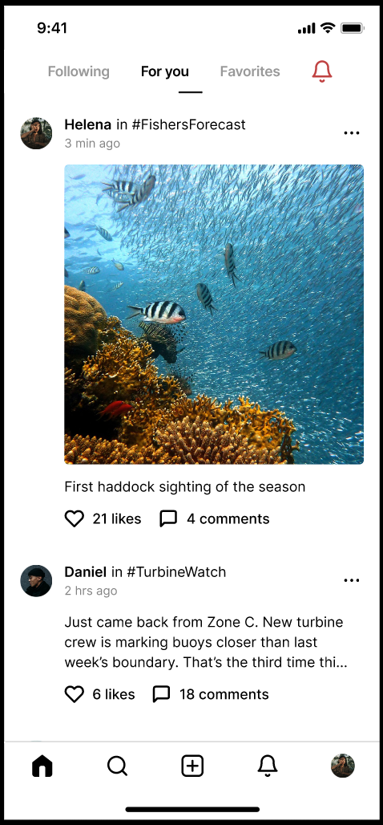



This button allows users in distress to send a GPS-tagged help alert and message to trusted contacts and Harbor Watch. Holding the red button prevents accidental taps. This feature underscores Tide Together’s commitment to trust and safety, particularly for fishers working in remote offshore zones.

Appendix B: “DockSwap: Give & Get Local” – Circular Exchange Interface

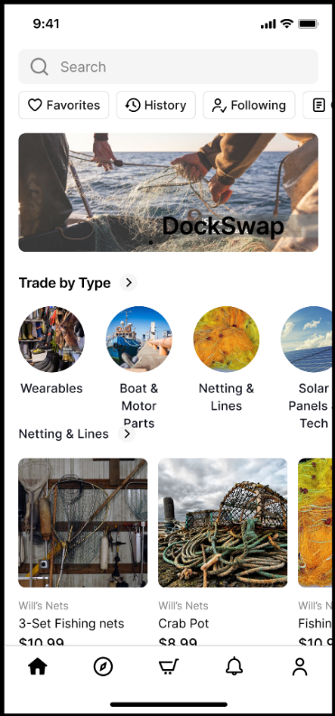

This screen demonstrates Tide Together's hyper-local barter system supporting sustainable living and gear reuse. Users can filter and post trade listings. It helps advance climate-friendly practices and builds community resilience.

Appendix C: “Safe Shore” – Mental Wellness and Cultural Legacy Screen

This screen offers Job opportunity resources, ability to post issues about the turbines anonymously, mental health resources, heritage stories, and peer support, responding to community grief around maritime identity loss. It directly addresses the emotional impact of energy transitions.

Appendix D: “Local Waters, Real Time” – Fishers Forecast Feed

  
This feed enables fishers to share and verify marine conditions, like currents or debris, using peer-sourced sightings. It integrates NOAA data with community knowledge, improving safety and trust.

Appendix E: “Community Pulse” – Social Awareness and Civic Alerts

**  
This redesigned social feed replaces “For You” with real-time zone updates, allowing users to post visual marine updates or tag turbine violations. It enhances civic engagement through tagged topics like #TurbineWatch.

Appendix F: “Marine Pulse Feed” – Smart Alerts & Activity Log

This updated notification tab shows tagged real-time activity like zoning changes, catch reports, or turbine compensation updates. It increases transparency and information flow.

Appendix G: “Zone Map View” – Interactive Zoning & Data Overlay Screen

This map interface shows overlay of turbine and fishing zones, incorporating real-time AI data on biodiversity and wind conditions. It equips residents to monitor and influence zoning decisions.